Pega Process AI

Process AI is provided as a low-code capability by Pega, a low code platform.

What is Process AI

Pega Process AI infuses automation with real-time workflow and event processing using which we can proactively predict and avoid SLA breaches, preemptively address delays and service issues and route work more effectively.

Before getting started we may familiarize ourselves with the following definitions before we get started

* Data Flow
* Strategy
* Models
* Predictions
* Prediction Studio

Models

AI’s core components are models. The models that Pega OOTB supports are listed below

Using a simplex matrix, the scorecard model calculates a score depending on the predictors.

The **adaptive model** uses its capacity for self learning to forecast the likelihood.

**Predictive models** use historical data to forecast probable future events, facilitates predictive as well as adaptive analysis.

**Text categorization** is based on ongoing conversations, forecasts sentiments and intent.

**Text extraction** is the process of identifying and classifying named things that are extracted from unstructured text, such emails and chat messages.

Prerequisites for running Process AI

In order to run Process AI in the platform applications, we will have to meet the below prerequisites

* For running a prediction with a simple score card model, the system should be configured with at least one data flow node
* For running a prediction with Adaptive/predictive model, the system should be configured with at-least one ADM, DDS, and data flow node.
* We will not require any additional applications/products to be installed in the system to use Process AI. This feature comes with Pega Platform.

Business Scenario

To see how pega process AI uses models and predictors to optimize process automation, lets look at a few real-world claim processing examples.

Scenario-

Whenever a claim is submitted in the system, business wants to make decision whether a fraud evaluation needs to be done on submitted claim based on below predictiors:

* Claim amount
* Vehicle type
* Vehicle speed

Business wants to have the predictions based on static business conditions and replaced by a predictive model based on historical data.

Implementation

Implementation can simply be categorized into three major steps

* Configuring Prediction
* Invoking prediction
* Executing prediction

Configuring Prediction

Login into prediction studio and launch the Create New Prediction wizard

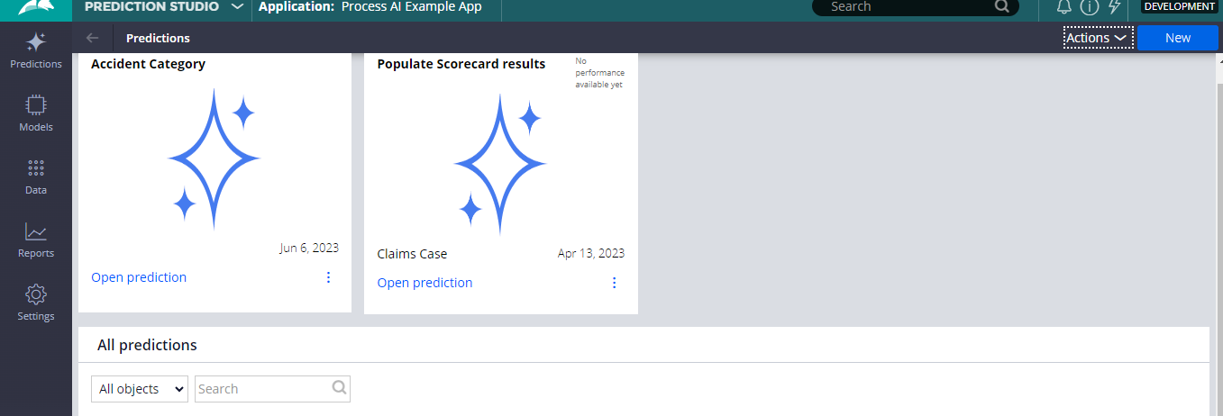

Proceed with creating a Case Management prediction.

System then generates a prediction rule with scorecard models that makes prediction if the case is normal or abnormal based on the predictors defined the model.

Invoking Prediction

Open the case type for which the prediction is created and add the prediction under the settings tab.

Once added, we can then use the propensity of the prediction to make decisions.

Fraud evaluation happens if the prediction return propensity ess than 0.5

Executing Prediction

As soon as we map the custom conditions using prediction. Pega generates a property of type Page and uses it to execute the prediction at run-time. System also generates Data Flow and Strategy rule of the same.

Once added then we can then use the propensity of the prediction to make decisions.

In the below example, fraud evaluation happens if the prediction return propensity less than 0.5.

Executing Prediction

As soon as we map the custom conditions using prediction, Pega generates a property of type Page and uses it to execute the prediction at run-time. System also generates Data Flow and Strategy rule for the same.

Now for every claim submission, claim amount entered will be evaluated against the scorecard model and based on the outcome(propensity) systems decides if fraud evaluation is required against the claim or not.

Implementation

Implementation can simply be categorized into three major steps

* Configuring prediction
* Invoking prediction
* Executing prediction

Unlike Fraud prediction case completion type dosen’t create the prediction rule directly. It requires few additional steps to be configured,

* Data Selection – processing historical data(if available)
* Prediction Configuration – selecting the positive and negative outcomes for the model
* Predictors selection – selecting the list of predictors to determine the pattern
* Prediction review- summary of the creation

System then generates a prediction rule with Adaptive Model which predicts if the case can likely be positive or negative

Now for every claim submission adaptive model records the case pattern and predicts if the case turn out to be positive or negative

Basically this is Process AI